October 30, 2023
Sewer Upgrades in Your Area – Phase 2
Contract: 22TW-CTS-08CWD
The City of Toronto will be rehabilitating existing sewer infrastructure in your area under Phase 2. The project is part of the Council-approved Capital Works Program to renew aging infrastructure, reduce the risk of leaks, and ensure continued long-term reliable sewer service. This project was planned to be delivered under two Phases as coordinated with other infrastructure improvements along Broadview Avenue to limit impacts to the local community. This includes the streetcar track replacement project and work at Broadview station. Phase 1 was of the sewer upgrades project was previously completed in June 2023.

This upcoming work Phase will occur at select locations along Broadview Avenue and on connecting side streets between Pretoria Ave. to Gerrard St. E. The work will occur intermittently starting on November 20th, 2023 through to February 17th, 2024. The work will take place through existing maintenance holes and will require localized lane restrictions during evening and overnight hours.
This work is essential to ensure the City’s infrastructure remains safe, in a state of good repair and able to meet Toronto’s needs.
This public notice contains important information. Please keep this public notice until the end of the construction period.

MAP OF LOCAL WORK AREA 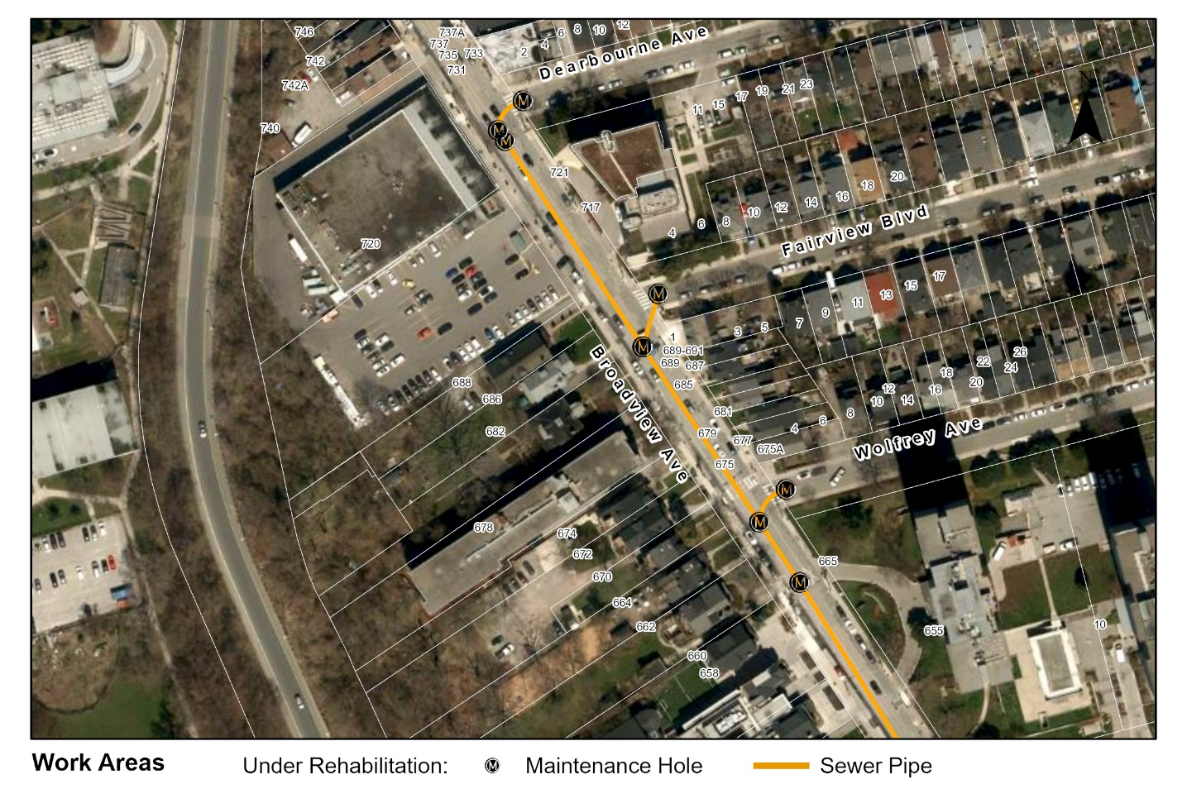

WORK DETAILS
This rehabilitation work includes cleaning the interior of existing sewers, installation of a structural liner inside existing sewers to seal cracks and/or joints, repairs to maintenance holes, as well as upgrades to the City-owned portion of sewer connections, where necessary.

The following work activities will be completed; 1) a condition assessment of the sewer is completed with a closed-circuit TV (CCTV) camera to verify the condition, 2) the sewer is cleaned of debris and hard deposits, and 3) a structural liner will be installed in the sewer to form a new Cured-In-Place Pipe (CIPP). You will receive a subsequent "Sewer Service Disruption" or "Odour" Notice prior to the lining activity starting.

WHAT TO EXPECT DURING ACTIVE CONSTRUCTION
 |  | Work Hours: Work will occur at night from 7 p.m to 7 a.m., Monday to Friday, unless site-specific conditions require alternative work hours and days. Note: Work will not take place on statutory holidays.
 |  | Construction Noise: You may experience intermittent noise and vibration during construction (from vacuum trucks, power generators, air compressors, etc.). All work will comply with the City of Toronto's Noise Bylaw.
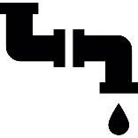 |  | Sewer Service Disruptions: The City-hired contractor will provide you with an additional "Sewer Service Disruption” Notice at least 48 hours in advance of the lining activities commencing. The Notice will outline the exact time and duration of the sewer service disruption, if applicable.  Please note that you will be asked to avoid allowing water down the drain during the period as indicated in the Notice. Water will not be shut off during the disruption, however, we will ask that you do not use a washing machine or dishwasher, flush your toilet, or use a sink, shower or bath without the use of a drain stopper during the temporary service disruption window. This is to avoid a sewer back-up while your sewer connection is temporarily sealed/plugged. When handwashing, please try to use a drain stopper.
 |  | 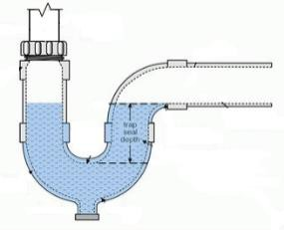  Odour: The work can cause strong "plastic or glue-like" short-term odours during and shortly after lining activities if your drain pipes do not have the required water barrier.  IMPORTANT: In order to avoid these strong odours, you will be asked to follow the instructions in the subsequent Notices. At that time, we recommend that you pour 1-2 litres of water down every drain (i.e. sinks, showers, bathtub, floor drains) in order to ensure a water barrier is present prior to the lining work. Do not continuously run your taps.  If any type of strong odour is present in your home during the work, please contact the Field Ambassador or the contractor’s emergency contact on their Notice for  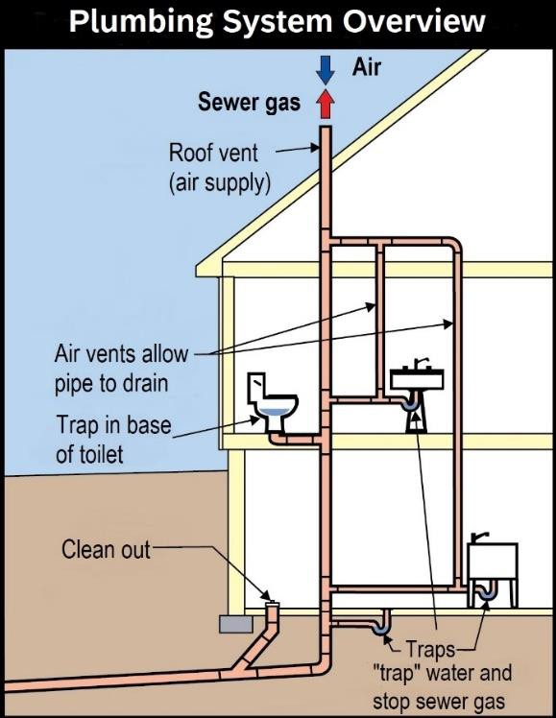  immediate assistance.  More information on odours and how to prevent them:  Drain pipes are designed as per Ontario Building Code to retain water after each use, in order to create a water barrier that prevents odours from entering your home (see illustration to the right.):  Residents should not smell odours in their house if they follow the instructions provided above and have a plumbing system that adheres to the current Ontario Building Code. If odours are present, you may have an internal plumbing issue (such as blocked roof vent stack, no vent, no trap, etc.). You may choose to hire a private plumber to investigate.
 |  | Road and Sidewalk Access: In order to complete the work in a safe manner, there will be localized road and sidewalk restrictions within the active construction work zone. Access for emergency vehicles will be maintained at all times.  Driveway Access: Typically, driveway access will not be restricted. If temporary restrictions to your driveway are necessary, the contractor will notify you directly in advance of the work.
 |  | Traffic Management: Efforts have been made to manage traffic in the area for the safety of workers, road users and residents. Road users may experience delays as a result of increased traffic on nearby main and side streets due to temporary lane restrictions in the work area as required to complete the work safely. Northbound and southbound traffic will be maintained along Broadview Ave.
 |  | Garbage & Recycling: Please follow your normal routine. If required, the contractor will move bins to an appropriate location and return them.  Please ensure that you label your bins with your address.
 |  | Parking: Prior to construction activities, "No Parking" signs will be placed in the work zone. Parking in the active work zone is not permitted due to space requirements for construction equipment and materials. If your parked vehicle is within the construction work zone where "no parking" signs are present, it will be re-located at the expense of the owner. If your vehicle is moved, please contact parking control for its location at 416-808-2222.  In the event you receive a traffic ticket for on-street parking during this period of construction, you may choose to dispute your ticket following the process listed on the reverse side of the parking infraction notice. You may use this notice as part  of your defence for parking consideration during construction; however, the Project Manager does not have the authority to cancel any parking tickets.
If you have questions about the work, please contact us and quote
Contract 22TW-CTS-08CWD
Field Ambassador | 647-362-9464, fieldambassador@andrews.engineer
TTY Hearing Impaired Service | 416-338-0889  (7 Days a week, 8 a.m.– 5 p.m., closed holidays)
General inquiries | 3-1-1

Thank you for your patience. Building a great city takes time. Better infrastructure for all of us is worth the wait.

